**Philosophy QA**

1. **Explain the charvaka notion of life. Founder: Brihasapti**

**About Charvakas:** [Charvaka](https://www.worldhistory.org/Charvaka/) (or Carvaka) was a philosophical school of thought, developed in [India](https://www.worldhistory.org/india/) c. 600 BCE, stressing materialism as the means by which one understands and lives in the world. Materialism holds that perceivable matter is all that exists; concepts such as the soul and any other supernatural entities or planes of existence are simply inventions of imaginative people.

Perception reveals to us only the material world, composed of the four bhūtas or elements of matter, viz. air, fire, water and earth, the existence of which we can directly know through the senses. All objects of this perceptible world are composed of these elements. There is no evidence that there is anything like an immaterial soul in man.

The meaning of the name is contested with some claiming it references the act of chewing since Charvaka emphasized the importance of enjoying life through eating and drinking. It is foolish to forgo the pleasures of life simply because they happen to be mixed with pain. We should try to get the best out of this life by enjoying it as best as we can and avoiding as far as possible the chances of pain.

**The Charvakas notion of life:**

The Charvaka vision rejected all supernatural claims, all religious authority and scripture, the acceptance of inference and testimony in establishing truth, and any religious ritual or tradition. The essential tenets of the [philosophy](https://www.worldhistory.org/philosophy/) were:

1. Direct perception as the only means of establishing and accepting any truth
2. What cannot be perceived and understood by the senses does not exist
3. All that exists are the observable elements of air, earth, fire, and water
4. The ultimate good in life is pleasure; the only evil is pain
5. Pursuing pleasure and avoiding pain is the sole purpose of human existence
6. [Religion](https://www.worldhistory.org/religion/) is an invention of the strong and clever who prey on the weak

Charvaka is thought to have been developed by Brhaspati (not to be confused with the great sage of light Brhaspati of Dharma Shastra fame) in response to what he perceived as the superstitious nonsense people were fooled into accepting as irrefutable truth.

Brhaspati's disciple, Charvaka, is thought by some to have developed his original vision. It is equally possible that Charvaka was its founder and Brhaspati the disciple and also possible that neither is true. The Brhaspati Sutra, said to be the central text of Charvaka, was lost or destroyed and any claims made regarding the philosophy should be viewed critically.

1. **What is the meaning of upanishad? Do upanishads accept the Vedic gods?**

The [Upanishads](https://www.worldhistory.org/Upanishads/) are the philosophical-religious texts of [Hinduism](https://www.worldhistory.org/hinduism/) which develop and explain the fundamental tenets of the [religion](https://www.worldhistory.org/religion/). The name is translated as to “sit down closely” as one would to listen attentively to instruction by a teacher or other authority figure.

They are the most recent part of the [Vedas](https://en.wikipedia.org/wiki/Vedas), the oldest scriptures of Hinduism, and deal with meditation, [philosophy](https://en.wikipedia.org/wiki/Indian_philosophy), [consciousness](https://en.wikipedia.org/wiki/Consciousness), and knowledge; whereas the Vedas deal with mantras, benedictions, rituals, ceremonies, and sacrifices.

While among the most important literature in the history of Indian religions and culture, the Upanishads document a wide variety of rites, departing from Vedic ritualism and interpreted in various ways in the later traditions of Hinduism.

Of all Vedic literature, the Upanishads alone are widely known, and their diverse ideas, interpreted in various ways, informed in the later traditions of Hinduism.

There are between 180-200 Upanishads but the best known are the 13 which are embedded in the four Vedas known as:

* Rig Veda
* Sama Veda
* Yajur Veda
* Atharva Veda

Do Upanishads accept Vedic gods-

[Vedic gods](https://en.wikipedia.org/wiki/Rigvedic_deities) such as the Agni, Aditya, Indra, Rudra, Visnu, Brahma, and others become equated in the Upanishads to the supreme, immortal, and incorporeal Brahman-Atman of the Upanishads, god becomes synonymous with self, and is declared to be everywhere, inmost being of each human being and within every living creature.

1. **What is the concept of Karma in Buddhism? | The Theory of Karma in Buddhism**

Karma is the law of moral causation. The theory of Karma is a fundamental doctrine in Buddhism. This belief was prevalent in India before the advent of the Buddha. Nevertheless, it was the Buddha who explained and formulated this doctrine in the complete form in which we have it today.

According to Lord Buddha, in this world nothing happens to a person that he does not for some reason or other deserve. Usually, men of ordinary intellect cannot comprehend the actual reason or reasons. The definite invisible cause or causes of the visible effect is not necessarily confined to the present life, they may be traced to a proximate or remote past birth.

According to Buddhism, this inequality is due not only to heredity, environment, "nature and nurture", but also to Karma. In other words, it is the result of our own past actions and our own present doings. We ourselves are responsible for our own happiness and misery. We create our own Heaven. We create our own Hell. We are the architects of our own fate.

The belief in the theory of Karma, it will be seen, is only an aspect of this doctrine. The present existence of an individual is, according to this doctrine, as according to that of karma, the effect of its past; and its future would be the effect of its present existence. This has been seen very clearly already in connection with the explanation of the origin of suffering in the light of the theory of dependent origination. The law of karma is only a special form of the more general law of causation as conceived by Buddha.

1. **According to the upanishads, what is the relation between Atman and Brahman?**

The phrase "Atman is Brahman" captures the Vedanta school's primary view about ultimate reality and our human relationship to it.

What does "Atman is Brahman" mean?

Let's break the phrase down into its two basic concepts.

First is "atman" - loosely translated, this means "soul" or "individual soul." Atman refers to the essence of each individual living thing - its soul or primary living energy. Each living thing - people, animals, plants - have an atman that forms each thing's eternal essence. Atman is immortal and eternal.

Brahman is "world soul" or "cosmic soul." It is the eternal essence of the universe and the ultimate divine reality. It is the life source of all that has been, is and will be throughout the entire cosmos. It is more like the primal ground or reality of all being and existence.

So, the phrase "atman is Brahman" is saying, quite simply, that the individual soul is the world soul.

In other words, each individual soul comes from and is made of the same reality as the world soul. There is no distinction between us, on the one hand, and the ultimate divine reality, on the other.

This is an amazing concept!

It basically means that in our deepest selves, we are divine. All living things are divine in their deepest selves. Now, that divine self may be hidden or covered over by hatred, envy, fear or other negative things. But, it is there nonetheless and it is our "true" and "eternal" selves.

1. **Explain briefly the metaphysical views of Buddhism.**

In metaphysics, the Buddha argues that there are no self-caused entities, and that everything dependently arises from or upon something else. This allows the Buddha to provide a criticism of souls and [personal identity](https://iep.utm.edu/person-i/); that criticism forms the foundation for his views about the reality of rebirth and an ultimate liberated state called “Nirvana.”

1. **Explain briefly the metaphysical views of Jainism.**

According to Jain thought, the basic constituents of reality are souls (jiva), matter (pudgala), motion (dharma), rest (adharma), space (akasa), and time (kala).

While Jainism is dualistic—that is, matter and souls are thought to be entirely different types of substance—it is frequently said to be atheistic.

What is denied is a creator god above all. The universe is eternal, matter and souls being equally uncreated. The universe contains gods who may be worshipped for various reasons, but there is no being outside it exercising control over it.

The gods and other superhuman beings are all just as subject to karma and rebirth as human beings are. By their actions, souls accumulate karma, which is understood to be a kind of matter, and that accumulation draws them back into a body after death.

Hence, all souls have undergone an infinite number of previous lives, and—with the exception of those who win release from the bondage of karma—will continue to reincarnate, each new life determined by the kind and amount of karma accumulated. Release is achieved by purging the soul of all karma, good and bad.

1. **Explain briefly the metaphysical views of Charvakas.**

Charvaka’s Metaphysics follows the logical consequence of its epistemology. There are 3 aspects to Charvaka’s metaphysics:

1. Acceptance of 4 elements

Charvaka accepts only 4 elements out of the 5 i.e Air, Water, Fire and Earth. It rejects space because space can’t be perceived. Using the 4 elements Charvaka explains the creation of consciousness. It states that the 4 elements are independent and have a conscience of their own, due to which they come together and merge, leading to the creation of life or consciousness.

2. Denial of God.

Charvaka completely denies the existence of God. Charvaka states that God can’t be perceived and that which can’t be perceived does not exist. Secondly, Charvaka has already credited the 4 elements for the creation of life and therefore denies that God is the being responsible for creation. As for any other belief related to God, Charvaka states that it is purely based on human faith and has no proof.

3. Denial of Soul

Since soul has a consciousness and Charvaka cannot deny consciousness Charvaka comes up with its own theory of soul. It denies the regularly accepted definition of soul i.e. soul is eternal and is a separate entity from human body. Charvaka says that soul is nothing but a body endowed with consciousness. Soul and body are one and inseparable.

To this there rises a criticism that if body and soul are one then why is it that the body can be perceived but the soul cannot. Thus leading to the self-contradiction of Charvaka’s own soul theory.

1. **What is religious pluralism? Problems of pluralistic society.**

Religious pluralism is the state of being where every individual in a religiously diverse society has the rights, freedoms, and safety to worship, or not, according to their conscience.

Example: India can be seen as the best example of religious pluralism. It is a nation with a Hindu majority but it is also home to various minority groups with different religious and cultural backgrounds.

A pluralist society is a diverse society, and a diverse society is one characterized by differences: religious differences, cultural differences, gender and sexual differences, economic differences, political differences, racial and ethnic differences, etc.

Today we can identify two challenges of pluralism: the ever-growing conflicts between religious, national and ethnic groups on the one hand and the oppression of dissenting individuals by their respective communities on the other hand.

1. **Make a detailed exposition of the Charvaka epistemology.**

The entire philosophy of the Cārvākas may be said to depend logically on their epistemology or the theory of knowledge. Knowledge of reality or valid cognition is called pramā and the source of such knowledge is called pramāṇa.

The Charvaka epistemology holds pramāṇa or perception as the primary and proper source of knowledge, while inference is held as prone to being either right or wrong and therefore conditional or invalid.

Perception are of two types, for Charvaka, external and internal. External perception is described as that arising from the interaction of five senses and worldly objects, while internal perception is described by this school as that of inner sense, the mind.

Inference is described as deriving a new conclusion and truth from one or more observations and previous truths. To Charvakas, inference is useful but prone to error, as inferred truths can never be without doubt.

Inference is good and helpful, it is the validity of inference that is suspect – sometimes in certain cases and often in others. To the Charvakas there were no reliable means by which the efficacy of inference as a means of knowledge could be established.

1. **Briefly explain Jaina Epistemology.**

Underlying Jain [epistemology](https://iep.utm.edu/epistemo/) is the idea that reality is multifaceted (anekanta, or ‘non-one-sided’), such that no single statement or set of statements captures the complete truth about the objects they describe.

Every school of Indian thought includes some judgment about the valid sources of knowledge (pramanas). While their lists of pramanas differ, they share a concern to capture the common-sense view; no Indian school is skeptical.

The Jain list of pramanas includes sense perception, valid testimony (including scriptures), extra-sensory perception, telepathy, and kevala, the state of omniscience of a perfected soul.

Notably absent from the list is inference, which most other Indian schools include, but Jain discussion of the pramanas seem to indicate that inference is included by implication in the pramana that provides the premises for inference.

That is, inference from things learned by the senses is itself knowledge gained from the senses; inference from knowledge gained by testimony is itself knowledge gained by testimony, etc.

1. **Examine the importance of the Doctrine of dependent origination in Buddhism.**

There is a spontaneous and universal law of causation which conditions the appearance of all events, mental and physical. This law (dharma or dhamma) works automatically without the help of any conscious guide.

In accordance with it, whenever a particular event (the cause) appears, it is followed by another particular event (the effect). 'On getting the cause, the effect arises.' The existence of everything is conditional, dependent on a cause. This is called the theory of dependent origination (Pratītyasamutpāda in Sanskrit and Paṭiccasamuppāda in Pāli).

This view, as Buddha himself makes clear, avoids two extreme views: on the one hand eternalism or the theory that some reality eternally exists independently of any condition and, on the other hand, nihilism or the theory that something existing can be annihilated or can cease to be.

Buddha claims, therefore, to hold the middle view, namely, that everything that we perceive possesses an existence but is dependent on something else, and that thing in turn does not perish without leaving some effect.

Buddha attaches so much importance to the understanding of this theory that he calls this the Dhamma. 'Let us put aside questions of the Beginning and the End.' he says, 'I will teach you the Dhamma: that being thus, this comes to be. He who sees the paṭiccasamuppāda sees the Dhamma, and vice-versa’.

Buddha also says that this theory is very profound. We have seen already how this theory is applied to the solution of the question regarding the origin of misery, as well as to that regarding the removal of misery.

**Or, use this answer**

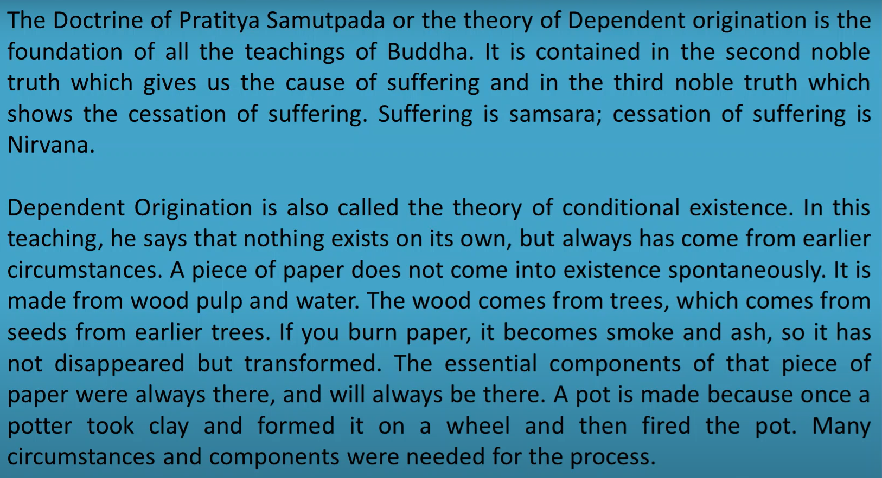

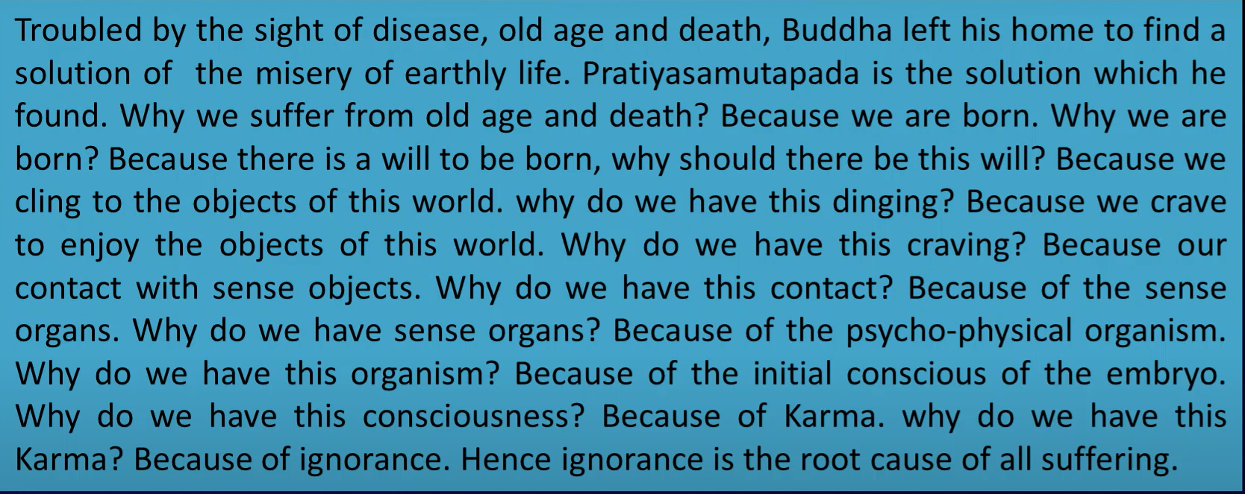

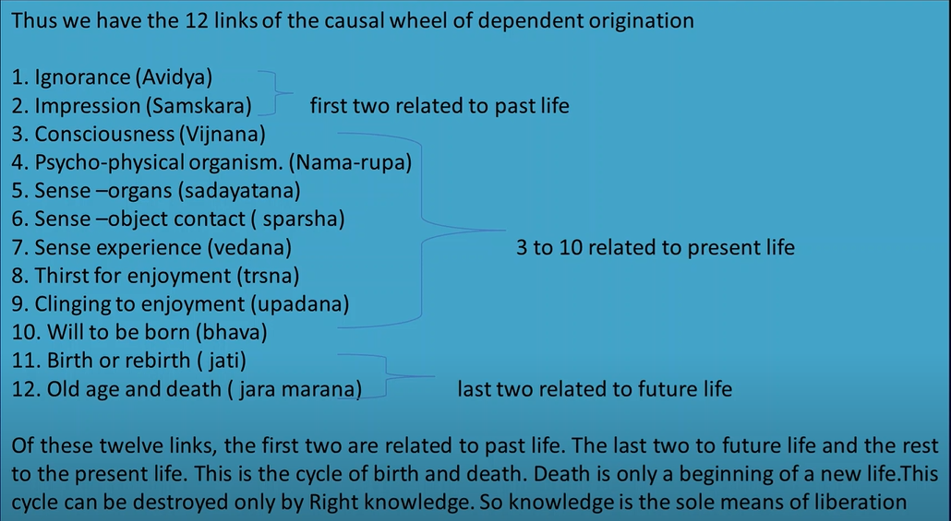

1. **Give a brief account of the meaning and classification of Vedas.**

The meaning of the word 'Veda' is derived from a Sanskrit word that insinuates 'knowledge'. These Vedas are considered as the depository house of knowledge. The Vedic followers are usually referred to as the Aryans.

There are only four types of Vedas namely - Samaveda, Yajurveda, Atharvaveda and Rigveda.

Rigveda: The earliest form of Veda and the oldest form of Veda is Rigveda. The meaning of the Rigveda asks to ‘Praise knowledge'.

Samaveda: Samaveda is also known to be the Veda for chants and tunes. It is also known as the storehouse of melodies. As India is known for its classical music and dance, the roots start from the introduction of Samaveda.

Yajurveda: The meaning of Yajurveda stands for 'worshipping knowledge’. Yajurveda has two types – Krishna which is considered to be (Black/Dark) & Shukla which is said to be(White/Bright).

Atharvaveda: This Veda comprises the daily routines and procedures of a normal life. There are a total of 20 books in Atharvaveda.

1. **What are the general characteristics of Indian Philosophy?**

**Common concerns**

The various Indian philosophies contain such a [diversity](https://www.merriam-webster.com/dictionary/diversity) of views, theories, and systems that it is almost impossible to single out characteristics that are common to all of them. Acceptance of the authority of the [Veda](https://www.britannica.com/topic/Veda)s characterizes all the orthodox (astika) systems—but not the unorthodox (nastika) systems, such as [Charvaka](https://www.britannica.com/topic/Charvaka) (radical materialism), Buddhism, and Jainism.

Three basic concepts form the cornerstone of Indian philosophical thought: the [self](https://www.britannica.com/topic/self) or [soul](https://www.britannica.com/topic/soul-religion-and-philosophy) ([atman](https://www.britannica.com/topic/atman)), works ([karma](https://www.britannica.com/topic/karma)), and liberation ([moksha](https://www.britannica.com/topic/moksha-Indian-religion)). Leaving the Charvakas aside, all Indian philosophies concern themselves with these three concepts and their interrelations, though this is not to say that they accept the objective validity of these concepts in precisely the same manner.

**Forms of argument and presentation**

There is, in relation to Western thought, a striking difference in the manner in which Indian philosophical thinking is presented as well as in the mode in which it historically develops.

Out of the presystematic age of the Vedic hymns and the Upanishads and many [diverse](https://www.merriam-webster.com/dictionary/diverse) philosophical ideas current in the pre-Buddhistic era, there emerged with the rise of the age of the [sutra](https://www.britannica.com/topic/sutra)s (aphoristic summaries of the main points of a system) a neat classification of systems (darshanas), a classification that was never to be contradicted and to which no further systems are added.

No new school was founded, no new darshana came into existence. But this conformism, like conformism to the Vedas, did not check the rise of independent thinking, new [innovations](https://www.merriam-webster.com/dictionary/innovations), or original insights.

There is, apparently, an underlying assumption in the Indian tradition that no individual can claim to have seen the truth for the first time and, therefore, that an individual can only explicate, state, and defend in a new form a truth that has been seen, stated, and defended by countless others before him—hence the tradition of expounding one’s thoughts by [affiliating](https://www.merriam-webster.com/dictionary/affiliating) oneself to one of the darshanas.

1. **Short note:**
2. **Atman:** Atman is a Sanskrit word, defined in simple terms as an individual’s inner self, spirit or soul. The concept of Atman as the true self is considered to be the first principle of Hindu philosophy, particularly according to the Vedanta tradition.

Atman in the Upanishad, is regarded as eternal and imperishable, distinct from the physical body, mind and consciousness. It is believed to be found within every living being, though some individuals do not recognize this true self due to ignorance or illusion, known as Maya.

1. **Brahman:** Brahman is a metaphysical concept of Hinduism referring to the ultimate unchanging reality, that is uncreated, eternal, infinite, the cause, the foundation, the source and the goal of all existence. It is envisioned as either the cause or that which transforms itself into everything that exists in the universe as well as all beings, that which existed before the present universe and time, and that which will absorb and exist after the present universe and time ends.

Though a variety of views are expressed in the Upanishads, they [concur](https://www.merriam-webster.com/dictionary/concur) in the definition of brahman as eternal, conscious, irreducible, [infinite](https://www.merriam-webster.com/dictionary/infinite), omnipresent, and the spiritual core of the [universe](https://www.britannica.com/science/universe) of finiteness and change.

1. **Samsara:** Saṃsāra is a [Pali](https://en.wikipedia.org/wiki/Pali)/[Sanskrit](https://en.wikipedia.org/wiki/Sanskrit) word that means "world". It is also the concept of rebirth and "cyclicality of all life, matter, existence", a fundamental belief of most [Indian religions](https://en.wikipedia.org/wiki/Indian_religions). Popularly, it is the cycle of death and [rebirth](https://en.wikipedia.org/wiki/Reincarnation). The concept of saṃsāra has roots in the post-[Vedic literature](https://en.wikipedia.org/wiki/Vedas); the theory is not discussed in the [Vedas](https://en.wikipedia.org/wiki/Vedas) themselves. It appears in developed form in the early [Upanishads](https://en.wikipedia.org/wiki/Upanishads). The full exposition of the saṃsāra doctrine is found in [Sramanic](https://en.wikipedia.org/wiki/Sramana" \o "Sramana) religions such as [Buddhism](https://en.wikipedia.org/wiki/Buddhism) and [Jainism](https://en.wikipedia.org/wiki/Jainism).
2. **Rta (Rit):** Dharma is identified with rta. Rta is the natural order which reveals itself in and through the world and reveals itself as a moral law, governing and regulating the human conduct. Thus, violating this adharma which is sinful and results in destruction or chaos. Rta is also identified with Satya, Yajna etc.
3. **Rna (Rin):** Rna means debts, or duties or obligations that we have to perform or repay. According to the Vedic and the Upanishadic world-view, each man is bound by some duties and obligation in life. These duties are not just the mere boundations but real modes of social freedom.
4. **Jagrata:** Jagrat is the Sanskrit term for one of the four states of consciousness of the mind, called avasthas in yogic philosophy. Jagrat is the waking state that people experience whenever they are not asleep. In jagrat, the mind is said to occupy the brain. It perceives external objects in the physical world through the senses, and it also identifies itself with the gross body, which is another external object.
5. **Svapna:** Svapna is a Sanskrit term for dream.  It encompasses both the content of the dream and the relationship of that content to the ordinary world.  In Sanskrit literature, dreams are a valid form of knowledge and an expression of reality, broadly speaking.
6. **Susupti:** Sushupti is a Sanskrit word meaning “deep sleep” and refers to one of the four states of consciousness in Hindu and yogic philosophy, sometimes called “deep sleep consciousness.” It is also the third of the three avasthas, or states of the mind. Sushupti is sometimes referred to as dreamless sleep, when the mind ceases activity, having withdrawn from both physical and mental activities, objects and desires. In sushupti, the mind has absorbed into itself.
7. **Turiya:** The state beyond deep, dreamless sleep, in which the superconscious becomes overtly active. Turiya is the fourth state of consciousness in which the individual rests in bliss. The individual has attained nirvikalpa samadhi or final liberation from ego consciousness and is united with infinite spirit. Turiya refers to both Atman, the individual self, and Brahman, the infinite self, representing their spiritual union.
8. **Karma:** Karma is the universal causal law by which good or bad actions determine the future modes of an individual’s existence. Karma represents the [ethical](https://www.merriam-webster.com/dictionary/ethical) dimension of the process of rebirth ([samsara](https://www.britannica.com/topic/samsara)), belief in which is generally shared among the religious traditions of India. The [doctrine](https://www.britannica.com/topic/doctrine) of karma directs adherents of Indian religions toward their common goal: release ([moksha](https://www.britannica.com/topic/moksha-Indian-religion)) from the cycle of birth and death. Karma thus serves two main functions within Indian [moral](https://www.britannica.com/topic/morality) philosophy: it provides the major motivation to live a [moral](https://www.merriam-webster.com/dictionary/moral) life, and it serves as the primary explanation of the existence of evil.
9. **Yoga:** The main philosophy of yoga is simple: mind, body, and spirit are all one and cannot be clearly separated. The ultimate goal of Yoga is a sustained state of pure awareness called Moksha or Samadhi. Yoga is the transcendence of the mind to realize the “true self” or “highest self.” This experience of pure consciousness is our true nature. In this state of liberation, all mental and philosophical constructs fall away. In essence, yogic philosophy is a necessary means to deepen one’s yoga practice and to reach enlightenment.
10. **Indian schools of philosophy. Categories and sub-categories sketch.**

**Difference between Astik schools and Nastik schools**

The basic difference between the two branches of Hindu Philosophy schools is said to be based on the recognition of Vedas. Orthodox schools recognize the authority of Vedas while heterodox schools don’t believe in the authority of Vedas.

Out of these nine systems, eight are atheistic as there is no place for God in them. Only Uttara Mimansa, which is also called Vedanta, has a place for God in it.

**Six Orthodox Schools (Classical Schools) of Indian Philosophy**

The 6 classical schools (shatdarshan) are Sankhya, Yoga, Nyaya, Vaisheshik, Purva Mimansa and Uttar Mimansa (Vedanta). Almost all Indian schools of thought accepted the theory of karma and rebirth, and the ideal of moksha is conceived as liberation from the cycle of births and deaths. Moksha/liberation is considered the highest goal of human struggle.

**1. Samkhya Philosophy - Kapila**

Sankhya is the oldest philosophy. It was put forward by Kapila.

Sankhya philosophy provided the materialistic ontology for Nyaya and Vaisheshik, but there is very little original literature in Sankhya.

It is generally believed that Sankhya Philosophy is dualistic and not monistic because it has two entities, purush (spirit) and prakriti (nature) in it. Samkhya emphasizes the attainment of knowledge of the self by means of concentration and meditation.

**Purush vs Prakriti:** In the beginning, the philosophy was materialistic as it talked only about Prakrithi, but later the element of purush was also added to it. While Purusha is posited as the only sentient being, ever-existent, and immaterial, Prakriti is said to be the material basis of this universe, composed of three basic elements (Gunas) – namely Tamas, Rajas, and Sattva.

**2. Yoga Philosophy - Patanjali**

Yoga presents a method of physical and mental discipline.

Yoga presents a practical path for the realization of the self whereas the Samkhya emphasizes the attainment of knowledge of the self by means of concentration and meditation. Releasing Purush from Prakriti by means of physical and mental discipline is the concept of Yoga.

The founder of Yoga is Patanjali. Yoga does not require belief in God, although such a belief is accepted as help in the initial stage of mental concentration and control of the mind.

**3. Nyaya Philosophy - Gautama**

Nyaya Philosophy states that nothing is acceptable unless it is in accordance with reason and experience (scientific approach). The founder of this philosophy is Gautam and the principles are mentioned in Nyaya Sutras. Nyaya says that the world is real and the philosophy does not follow a monist view.

Nyaya philosophy relies on several pramanas i.e. means of obtaining true knowledge as its epistemology. According to it, the pradhan pramana or principal means of obtaining knowledge is pratyaksha pramana i.e. the knowledge obtained through the 5 senses. There are also other pramanas like anumana (inference, through which we can obtain true knowledge) and shabda pramana (a statement of an expert).

**4. Vaisheshika Philosophy - Kannada**

The classical Indian philosophy Vaisheshika was the physics of ancient times. It propounded the [atomic theory](https://www.clearias.com/chemistry-basics/) of its founder Kannada. At one time Vaisheshika was regarded as part of the Nyaya philosophy since physics is part of science. Vaisheshika is a realistic and objective philosophy of the universe.

**5. Purva mimansa (mimansa) - Jamini**

The word Mimamsa means to analyze and understand thoroughly.  Purva Mimamsa examines the teachings of the Veda in the light of karma-kanda rituals, ie karma-mimamsa system is called purva-mimamsa. Purva mimansa (or briefly mimansa) lays emphasis on the performance of the yagya for attaining various spiritual and worldly benefits.

**6. Uttara Mimamsa (Vedanta) - Gaudapada**

Vedanta says that the world is unreal, Maya. Vedanta is monistic, in other words, it says that there is only one reality, Brahman. Vedanta lays emphasis on brahmagyan, hence relies on the Upanishad part of the Vedas. Vedanta has its roots in Sankya Philosophy.

**Three Heterodox Schools of Indian Philosophy**

Schools that do not accept the authority of Vedas are by definition unorthodox (nastika) systems. The following schools belong to heterodox schools of Indian Philosophy.

**1. Carvaka**

It is characterised as a materialistic and aesthetic school of thought. Accepted direct perception as the surest method to prove the truth of anything. Insists on joyful living. Also known as Lokayata, Carvaka is a materialistic school of thought. Its founder was Carvaka, author of the Barhaspatya Sutras.

**2. Buddhist Philosophy**

It is a system of beliefs based on the teachings of Siddhartha Gautama. [Buddhism](https://www.clearias.com/buddhist-councils/) is a non-theistic philosophy whose tenets are not especially concerned with the existence or non-existence of God.

Four Noble Truths in Buddhism are the following.

* There is suffering
* There is a cause of suffering
* There is a cessation of suffering
* There is a way to cessation of suffering

Buddhists philosophy of life to get ‘Nirvana’ from suffering is based on the following eight principles:

* Right Intention (Samyak Dristi)
* Right Livelihood (Samyak Sankalpa)
* Right Speech (Samyak Vakya)
* Right Action (Samyak Karmanta)
* Right Living ( Samyak Ajiva)
* Right View (Samyak Smriti)
* Right concentration (Samyak Samadhi)
* Right Effort (Samyak Vyayama)

**3. Jain Philosophy**

Already in existence by the 6th century B.C, it was revived by Mahavira, the 24th Jain Tirthankara. According to Jainism, Nirvana or liberation is obtained through three jewels: Right Philosophy, Right Knowledge and Right Conduct (Tri-ratna). Right conduct implies 5 abstinences: not to lie, not to steal, not to strive for luxury and not to strive for possessions, not to be unchaste and not to injure (Ahimsa).

1. **Inference is not certain – Charvaka epistemology. Explain**

The Charvaka [epistemology](https://en.wikipedia.org/wiki/Epistemology) holds perception as the primary and proper source of knowledge, while inference is held as prone to being either right or wrong and therefore conditional or invalid.

Inference is described as deriving a new conclusion and truth from one or more observations and previous truths. To Charvakas, inference is useful but prone to error, as inferred truths can never be without doubt.

Inference is good and helpful, it is the validity of inference that is suspect – sometimes in certain cases and often in others. To the Charvakas there were no reliable means by which the efficacy of inference as a means of knowledge could be established.

Charvaka's epistemological argument can be explained with the example of fire and smoke. It states that when there is smoke, one's tendency may be to leap to the conclusion that it must be caused by fire. While this is often true, it need not be universally true, everywhere or all the times, stated the Charvaka scholars. Smoke can have other causes.

In Charvaka epistemology, as long as the relation between two phenomena, or observation and truth, has not been proven as unconditional, it is an uncertain truth. In this Indian philosophy such a method of reasoning, that is jumping to conclusions or inference, is prone to flaw.

Charvakas further state that full knowledge is reached when we know all observations, all premises and all conditions. But the absence of conditions, state Charvakas, cannot be established beyond doubt by perception, as some conditions may be hidden or escape our ability to observe. They acknowledge that every person relies on inference in daily life, but to them if we act uncritically, we err.

1. **Testimony is not a safe source of language – Charvaka epistemology. Explain**

Inference is based on Vyapti gyan. but according to charvaka Vyapti gives rise to the fallacy of illicit generalization. So inference can’t be accepted as a pramana.

Charvakas have refuted verbal testimony as a valid source of knowledge because it is based on the statement of some reliable person/ scripture. And to find a reliable person is based on inference which is not a valid source of knowledge.

Comparison is also not accepted as the source of valid knowledge by charvakas. we can find knowledge of similarity through perception so no need of a separate pramana for that.

But in process of refuting other pramanas charvakas themselves have taken help of inference. Also, accepting that perception always gives reliable and authentic knowledge, leads to the fallacy of illicit generalization. It also limits our scope of knowledge.

In this way charvakas have left many a loopholes for criticism and debate in their epistemology.

1. **Charvaka Ethics**

The Carvaka ethics is based on the assumption that the human beings get annihilated at the point of death. She or he begins life with birth and ends it with death. Carvakas do not believe in the theory of karma and accordingly they reject the notion of re-birth after death. Since this is the only life for the individual, their exhortation is: “make the best use of it.”

To get the best out of this only life, one has to enjoy this life and to seek the utmost pleasure. The basic desire of every being/creature is to gain pleasure and avoid pain. Pleasure in this life is the sole end of man. Pleasure goes with pain. But on account of this, you should not run away from pleasure. The fact that there is pain in life should not deter the human beings from pursuing pleasure. Some of the sayings of Carvakas encourage us not to be bogged down by the presence of pain in the process of seeking pleasure.

1. **Jainism concept and terminologies.**
2. **Sat:** Sat means existence. It exists because of self-proven existence nature of substances (dravya) of which the world is constituted of. Sat is never lost and asat (opposite of sat) can never be achieved. Word sat is used widely in Jain meta-physics.

Jainism believes that sat, i.e., the reality, is uncreated and eternal and further asserts that sat, i.e., the reality, is characterized by: origination or appearance, vyaya, i.e., destruction or disappearance, and permanence.

1. **Dravya:** Dravya “substance” is a fundamental concept of [Jainism](https://www.britannica.com/topic/Jainism) to separate matter and [soul](https://www.britannica.com/topic/soul-religion-and-philosophy) completely. The Jains recognize the existence of five astikayas (eternal categories of being) which together make up the dravya (substance) of existence. These five are [dharma](https://www.britannica.com/topic/dharma-religious-concept), [adharma](https://www.britannica.com/topic/adharma), [akasha](https://www.britannica.com/topic/akasha-Jainism), [pudgala](https://www.britannica.com/topic/pudgala), and [jiva](https://www.britannica.com/topic/jiva).
2. **Guna:** Guṇa is a term in Jainism for the attributes or quality of [Dravya](https://en.wikipedia.org/wiki/Dravya" \o "Dravya), or substance. As per [Jain cosmology](https://en.wikipedia.org/wiki/Jain_cosmology), the universe is made up of Dravya, or substances, that are infinite in number but fall into six by categories. The concepts of Guṇa (attributes) and Dravya (substances) are what differentiates Jain worldview from Buddhist worldview. The Jain worldview claims that real cause of all the phenomena in the universe is the attributive and substantive base of those phenomena whereas Buddhist Worldview denies the existence of attributive or substantive base for any of the phenomena in the universe.
3. **Paryaya:** Each entity continuously undergoes countless changes. During this process the old form (size, shape etc.) of an entity is destroyed, the new form is originated. The form of a substance is called Paryaya. In the midst of modification of a substance, its certain qualities remain unchanged (permanence). The unchanged qualities of a substance are collectively known as Dravya.
4. **Jiva:** Jīva or soul is a philosophical term used within [Jainism](https://en.wikipedia.org/wiki/Jainism) to identify the [soul](https://en.wikipedia.org/wiki/Soul_(spirit)). As per [Jain cosmology](https://en.wikipedia.org/wiki/Jain_cosmology), jīva or soul is the principle of [sentience](https://en.wikipedia.org/wiki/Sentience) and is one of the [tattvas](https://en.wikipedia.org/wiki/Tattva_(Jainism)) or one of the fundamental substances forming part of the universe.
5. **Ajiva:** Ajiva ([Sanskrit](https://en.wikipedia.org/wiki/Sanskrit)) is anything that has no soul or life, the polar opposite of "[jīva](https://en.wikipedia.org/wiki/J%C4%ABva_(Jainism)" \o "Jīva (Jainism))" (soul). Because ajiva has no life, it does not accumulate karma and cannot die. Examples of ajiva include chairs, computers, paper, plastic, etc.
6. **Anekantavada:** Anekantavada defines Jain philosophy, which means “multiplicity of reality”. As per the Anekantavada, there are seven standpoints or principles called Saptabhangi. An object can have positive as well as negative qualities/states. Also, an object can have infinite states/modes which may or may not be known to the ordinary man. Paryaya basically defines the various modes or states of the object.

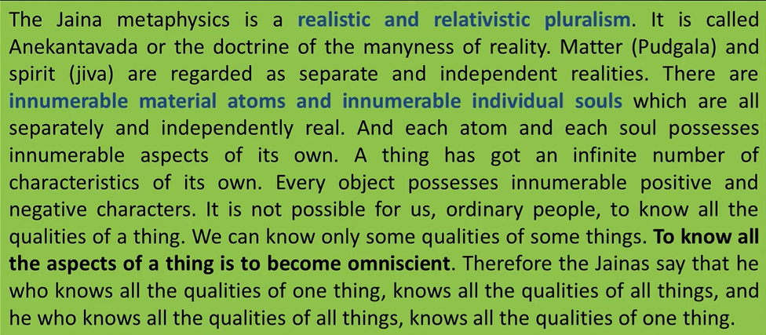

1. **Syadvada:** Syadvada, in Jaina metaphysics, the doctrine that all judgments are conditional, holding good only in certain conditions, circumstances, or senses, expressed by the word syat (“may be”). The ways of looking at a thing (called naya) are infinite in number. Syadavada literally means the ‘method of examining different probabilities.’
2. **Syadvada vs Anekantvada:** The basic difference between them is that Anekantavada is the knowledge of all differing but opposite attributes whereas Syadvada is a process of the relative description of a particular attribute of an object or an event.
3. **Nayavada:** Nayavāda (Skt., naya, ‘viewpoints’). In Jain philosophy, the doctrine of viewpoints, sometimes called the doctrine of relative pluralism. This doctrine is a unique instrument of analysis which asserts that all viewpoints are only partial expressions of the truth. No statement can be absolutely true because it is a view arrived at from only one angle or one particular standpoint.
4. **Pramanas:** Jain philosophy accepts three reliable means of knowledge ([pramana](https://en.wikipedia.org/wiki/Pramana" \o "Pramana)). It holds that correct knowledge is based on perception ([pratyaksa](https://en.wikipedia.org/wiki/Pratyaksha" \o "Pratyaksha)), inference ([anumana](https://en.wikipedia.org/wiki/Anumana" \o "Anumana)) and testimony (sabda or the word of scriptures).
5. **Ahimsa:** Ahimsa means to be without harm; to be utterly harmless, not only to oneself and others, but to all forms of life, from the largest mammals to the smallest bacteria. Jains believe that life (which equals soul) is sacred regardless of faith, caste, race, or even species.
6. **Bondage:** Bandha in Jainism, is the mutual intermingling of the [soul](https://en.wikipedia.org/wiki/Soul_(Jainism)) and [karmas](https://en.wikipedia.org/wiki/Karma_in_Jainism) (fine matter). Bandha (Bondage) comes immediately after the [asvara](https://en.wikipedia.org/wiki/Asrava" \o "Asrava) (influx of karmas).
7. **Liberation:** Moksha refers to the liberation or salvation of a soul from [saṃsāra](https://en.wikipedia.org/wiki/Sa%E1%B9%83s%C4%81ra_(Jainism)" \o "Saṃsāra (Jainism)), the cycle of birth and death. It is a blissful state of existence of a soul, attained after the destruction of all [karmic bonds](https://en.wikipedia.org/wiki/Karma_in_Jainism).
8. **The Jaina Theory of Judgment**

**(i) Syādvāda or the Theory that Every Judgment is Relative | Relative Pluralism**

The Jainas point out that the different kinds of immediate and mediate knowledge that we possess about objects show that every object last innumerable characters.

But imperfect beings look at objects from one particular point of view at a time and have consequently the knowledge of only one aspect or character of the thing.

Such partial knowledge about one of the innumerable aspects of an object is called by the Jaina writers ‘naya’. Judgment (paramarsa) based on such partial knowledge is also called a ‘naya’.

Every judgment that we pass in daily life about any object is, therefore, true only in reference to the standpoint occupied and the aspect of the object considered.

It is because we forget this limitation and regard our judgments as unconditionally true, that we come to quarrel and disagree very often in life.

The story of the blind men who formed their ideas of an elephant by touching its legs, ears, tail and trunk respectively and thus came to quarrel about the real shape of the animal, illustrates this truth.

They quarrelled because each thought that his knowledge was the only true and complete knowledge and should be accepted unconditionally.

The quarrel was over as soon as each of them realised that his knowledge was only of one of the many parts of the animal.

The various systems of philosophy which give different accounts of the universe similarly occupy different points of view and discover the different aspects of the many-sided universe.

They quarrel because they do not bear in mind that each account is true only from its own standpoint, and is subject to certain conditions. They fail to realise, therefore, that the different views may be true like the different descriptions of the elephant.

In view of these facts, the Jainas insist that every judgment (naya) should be qualified by some word like ‘somehow’ so that the limitation of this judgment and the possibility of other alternative judgments from other points of view may be always clearly borne in mind.

For example, instead of a judgment like ‘the elephant is like a pillar’, it should be said, to remove the chance of confusion, ‘Somehow (i.e., in respect of its legs, the elephant is like a pillar)’.

Similarly, on perceiving a black earthen jug existing in a room at a particular time, we should not assert unconditionally. ‘The jug exists’, but should rather say.

‘Somehow, the jug exists’, which would remind us that the judgment is true only with regard to the many conditions of space, time, quality, etc., under which the jug exists.

The qualified judgment ‘Somehow, the jug exists’ (syad ghatah asti) would prevent the possibility of the misapprehension that the pot exists at all times or in every place, or that a pot of any other colour, shape, etc., exists. The unqualified judgment, ‘The jug exists’, leaves; his possibility of such misapprehension

The theory of the Jainas has come to be known as syadvada. It is the view that every ordinary judgment (passed by imperfect minds like ours) holds good only of the particular aspect of the object judged and of the point of view from which the judgment is passed.

This Jaina view is quite in keeping with the view accepted by Western logicians generally, namely, that every judgment is passed in a particular universe of discourse or context and must be understood only in reference thereto.

The universe of discourse is constituted by different factors like space, time, degree, quality, etc., which are left unmentioned partly because they are obvious and partly because the/ are too many to be stated exhaustively.

Now, if these conditions cannot be exhaustively enumerated, as some modern logicians like Schiller also admit, it is good for the sake of precision to qualify the judgment explicity by a word like ‘somehow’ (syat).

The principle underlying ‘syadvada’ makes Jaina thinkers catholic in their outlook. They entertain and accept the views of other philosophers as different possible versions of the universe from different points of view.

The only thing that the jainas dislike in other thinkers is the dogmatic claim of each that he alone is in the right. This claim leads to the fallacy of exclusive predication (ekanta-vada).

Against such a fallacy of philosophical speculation a protest has been raised recently in America by the Neo-realists who have called it the fallacy of exclusive particularity.

But no Western or Eastern philosopher has so earnestly tried to avoid this error in practice as the Jainas have done.

**(ii) Saptabhaṅginaya or the Seven Forms of Judgment**

Ordinarily, logic distinguishes two kinds of judgment, affirmative and negative. The Jainas distinguish seven kinds of judgment including these two.

Any object may be described affirmatively by a judgment which predicates of it any of the characters it possesses, or it may be described negatively by a judgment which denies of it characters belonging to other objects but absent in this.

Judgments can then be symbolically represented as somehow k is P’ (syat asti). Again, negative judgments about an object would be like ‘somehow the jar is not outside the room’ meaning that the jar of that particular kind, at that particular time, etc., is not outside); ‘somehow the jar is not black (i.e., not black at that particular space and time and under those conditions, etc.).

We find then that the general form of all negative judgments is ‘somehow S is not P’ (syat nasti).

When, however, we have to describe the complex fact that the jar is sometimes red and sometimes not, we must have a compound judgment like ‘somehow the jar is and also is not red’.

The general form of this judgement would, therefore, be ‘somehow S is and also is not P’ (syat Asti canasti ca). This is the third form of judgment recognised byjaina logic.

This form is obtained by combining successively the points of view of the first two judgments into one composite point of view.

The necessity of such compound judgment lays in the need of a comprehensive view of the positive anc the negative characters of an object.

Ajar is black when raw and red when it is baked. But if we are asked, what is the real colour of the jar always or under all conditions, the only honest reply would be that the jar cannot be described then, i.e., under the conditions of the question.

Under such circumstances when we are forced to predicate simultaneously, of any object, characters which are incompatible, being contrary or contradictory, our judgment, according to the Jainas, would be of the general form ‘somehow S is indescribable (syat avak:avyam). This is the fourth kind of judgment recognised by Jaina logic.

Recognition of this fourth form of judgment is of great philosophical value. It points out; first, that thought of an object can be described from cifferent standpoints.

In different aspect separately or successively; it cannot be described at all, if no sub distinction of standpoint; and aspect is made.

An object is an indescribable entity. Secondly, this also points out that philosophical wisdom does not always consist in the ability to W a straight affirmative or negative, but also realising that some questions, by their very nature, are unanswerable.

Thirdly, the recognition of this form of judgment shows that the Jaina logic does not violate the principle of contradiction.

On the contrary, it shows that obedience to this law makes the Jaina confess that incompatible characters cannot be simultaneously predicated of any subject in the same aspect.

The other three, of the seven forms of judgment, are obtained by combining successively each of the first three standpoints with the fourth.

Thus by combining the first and the fourth successively, we get the fifth form of judgment, ‘somehow S is P is also when we consider together, from a comprehensive point of view.

The fact that is sometimes red, but also that without reference to any particular time or state it cannot be described as having any predicable character, our judgment is of the form, ‘The jug is somehow red but is also somehow indescribable.’

If we combine simultaneously any of the first three points of view with the fourth, instead of doing so successively, we shall have in each case the simultaneous predication of incompatible characters like ‘is and is indescribable’; or ‘is not and is ‘indescribable’; or ‘is, is not and is indescribable’. Hence in eachCase judgment would be the same in form as in the fourth.

1. **Jaina Ethics – Jainism as a religion without God.**

Jainism believes that universe and all its substances or entities are eternal. It has no beginning or end with respect to time. Universe runs own its own accord by its own cosmic laws. All the substances change or modify their forms continuously. Nothing can be destroyed or created in the universe. There is no need of someone to create or manage the affairs of the universe. Hence Jainism does not believe in God as a creator, survivor, and destroyer of the universe.

However, Jainism does believe in God, not as a creator, but as a perfect being. When a person destroys all his karmas, he becomes a liberated soul. He lives in a perfect blissful state in Moksha forever. The liberated soul possesses infinite knowledge, infinite vision, infinite power, and infinite bliss. This living being is a God of Jain religion.

Every living being has a potential to become God. Hence Jains do not have one God, but Jain Gods are innumerable and their number is continuously increasing as more living beings attain liberation.

Jains believe that since the beginning of the time every living being (soul) is attached with karma and also it is in delusion (ignorant) state of its true nature. The main purpose of the religion is to remove this delusion through self-knowledge and self-effort. This knowledge will remove karma which are associated with it from the beginning of time. When all karma gets removed, the soul becomes liberated soul.

1. **Jainas criticise Carvaka views on inference.**

Carvaka's views on inference has been criticised by many thinkers and philosophical schools. According to them, first of all, inference is inescapable for Carvaka himself. To refuse the validity of inference is to refuse to think and discuss. All thoughts, all discussions, all doctrines, all affirmations and denials, all proofs and disproofs are made possible by inference.

It is through inference, not through sense-perception that the Carvaka knows what the other doctrines are, and it is through inference that the Carvaka hopes to convince others of the soundness of his argument.

Secondly, the rejection of inference itself is self-contradictory. That all inferences are invalid is itself an inference, which the Carvaka must admit.

1. **The Four Noble truths in Buddhism | In depth**

The Buddha's first sermon after his [enlightenment](https://www.learnreligions.com/what-is-enlightenment-449966) centered on the Four Noble Truths, which are the foundation of Buddhism. One way to understand the concept is to view the Truths as hypotheses, and [Buddhism](https://www.learnreligions.com/introduction-to-buddhism-449715) as the process of verifying those hypotheses, or realizing the truth of the Truths.

The Four Noble Truths

A common, sloppy rendering of the Truths tells us that life is suffering; suffering is caused by greed; suffering ends when we stop being greedy; the way to do that is to follow something called the Eightfold Path.

In a more formal setting, the Truths read:

* The truth of suffering (dukkha)
* The truth of the cause of suffering (samudaya)
* The truth of the end of suffering (nirhodha)
* The truth of the path that frees us from suffering (magga)

Quite often, people get hung up on "life is suffering" and decide Buddhism isn't for them. However, if you take the time to appreciate what the Four Noble Truths are really about, everything else about Buddhism will be much clearer. Let's look at them one at a time.

**The First Noble Truth**

The [First Noble Truth](https://www.learnreligions.com/the-first-noble-truth-450089) is often translated as "life is suffering." This is not as dire as it sounds; it's actually quite the opposite, which is why it can be confusing.

Much confusion is due to the English translation of the Pali/Sanskrit word [dukkha](https://www.learnreligions.com/life-is-suffering-what-does-that-mean-450094) as "suffering." Dukkha also refers to anything that is temporary, conditional, or compounded of other things. Even something precious and enjoyable is dukkha because it will end.

Further, the Buddha was not saying that everything about life is relentlessly awful. In other sermons, he spoke of many types of happiness, such as the happiness of family life. But as we look more closely at dukkha, we see that it touches everything in our lives, including good fortune and happy times.

**The Second Noble Truth**

The [Second Noble Truth](https://www.learnreligions.com/the-second-noble-truth-450092) teaches that the cause of suffering is greed or desire. The actual word from the early scriptures is tanha, and this is more accurately translated as "thirst" or "craving."

We continually search for something outside ourselves to make us happy. But no matter how successful we are, we never remain satisfied. The Second Truth is not telling us that we must give up everything we love to find happiness. The real issue here is more subtle; it's the [attachment](https://www.learnreligions.com/why-do-buddhists-avoid-attachment-449714) to what we desire that gets us into trouble.

The Buddha's teachings on [karma](https://www.learnreligions.com/buddhism-and-karma-449992) and rebirth are closely related to the Second Noble Truth.

**The Third Noble Truth**

The Buddha's teachings on the Four Noble Truths are sometimes compared to a physician diagnosing an illness and prescribing a treatment. The first truth tells us what the illness is and the second truth tells us what causes the illness. The Third Noble Truth holds out hope for a cure.

The solution to dukkha is to stop clinging and attaching. But how do we do that? The fact is that it cannot be accomplished by an act of will. It's impossible to just vow to yourself, from now on I won't crave anything. This doesn't work because the conditions that give rise to craving will still be present.

The Second Noble Truth tells us that we cling to things we believe will make us happy or keep us safe. Grasping for one ephemeral thing after another never satisfies us for long because it's all impermanent.

**The Fourth Noble Truth**

In the [Fourth Noble Truth](https://www.learnreligions.com/the-fourth-noble-truth-450091), the Buddha as a physician prescribes the treatment for our illness: [The Eightfold Path](https://www.learnreligions.com/the-eightfold-path-450067). Unlike in many other religions, Buddhism has no particular benefit to merely believing in a doctrine. Instead, the emphasis is on living the doctrine and walking the path.

The path is eight broad areas of practice that touches every part of our lives. It ranges from study to ethical conduct to what you do for a living to moment-to-moment mindfulness. Every action of body, speech, and mind are addressed by the path. It is a path of exploration and discipline to be walked for the rest of one's life.

Without the path, the first three Truths would just be a theory. The practice of the Eightfold Path brings the [dharma](https://www.learnreligions.com/what-is-the-buddha-dharma-449710) into one's life and makes it bloom.

1. **The Four Noble Truths | In brief**

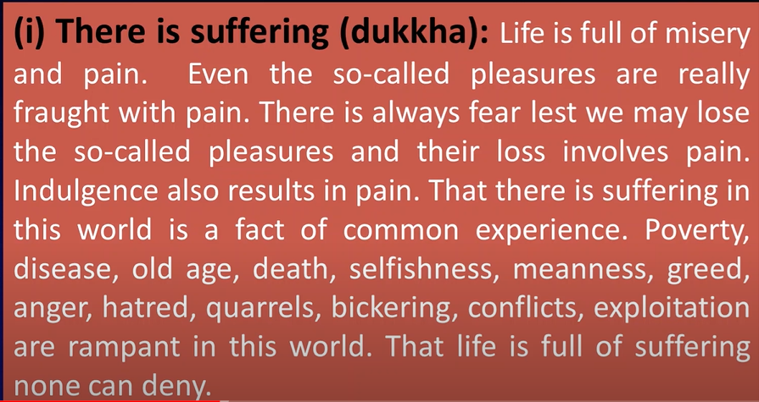

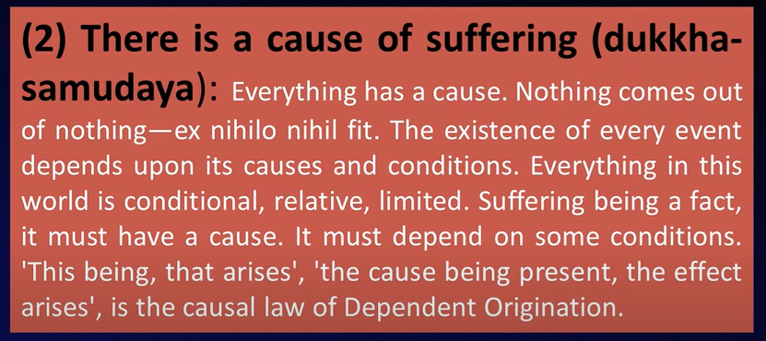

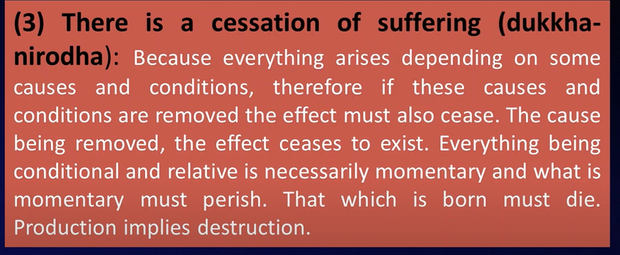

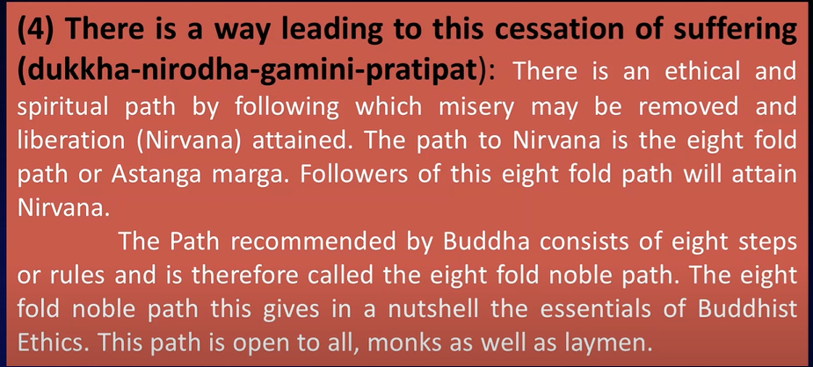

1. **THE EIGHT FOLD PATH**

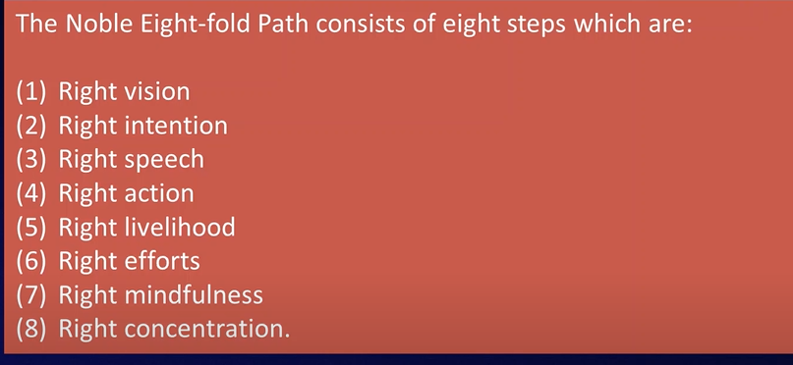

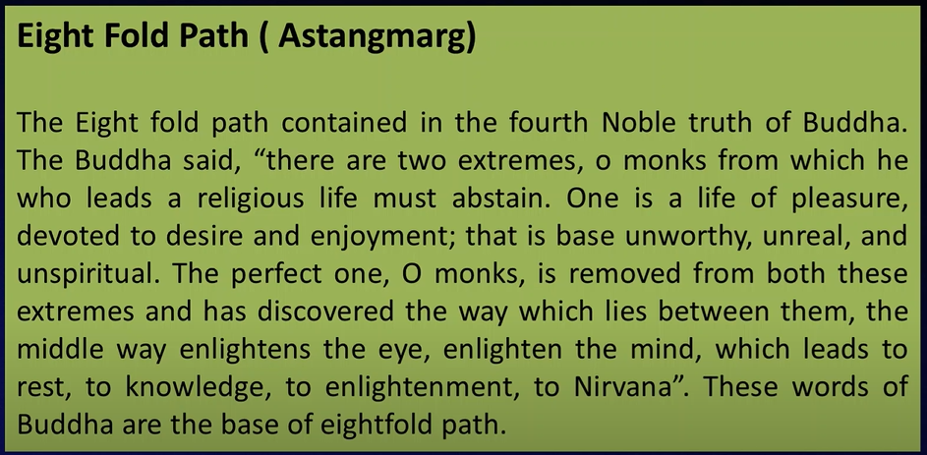

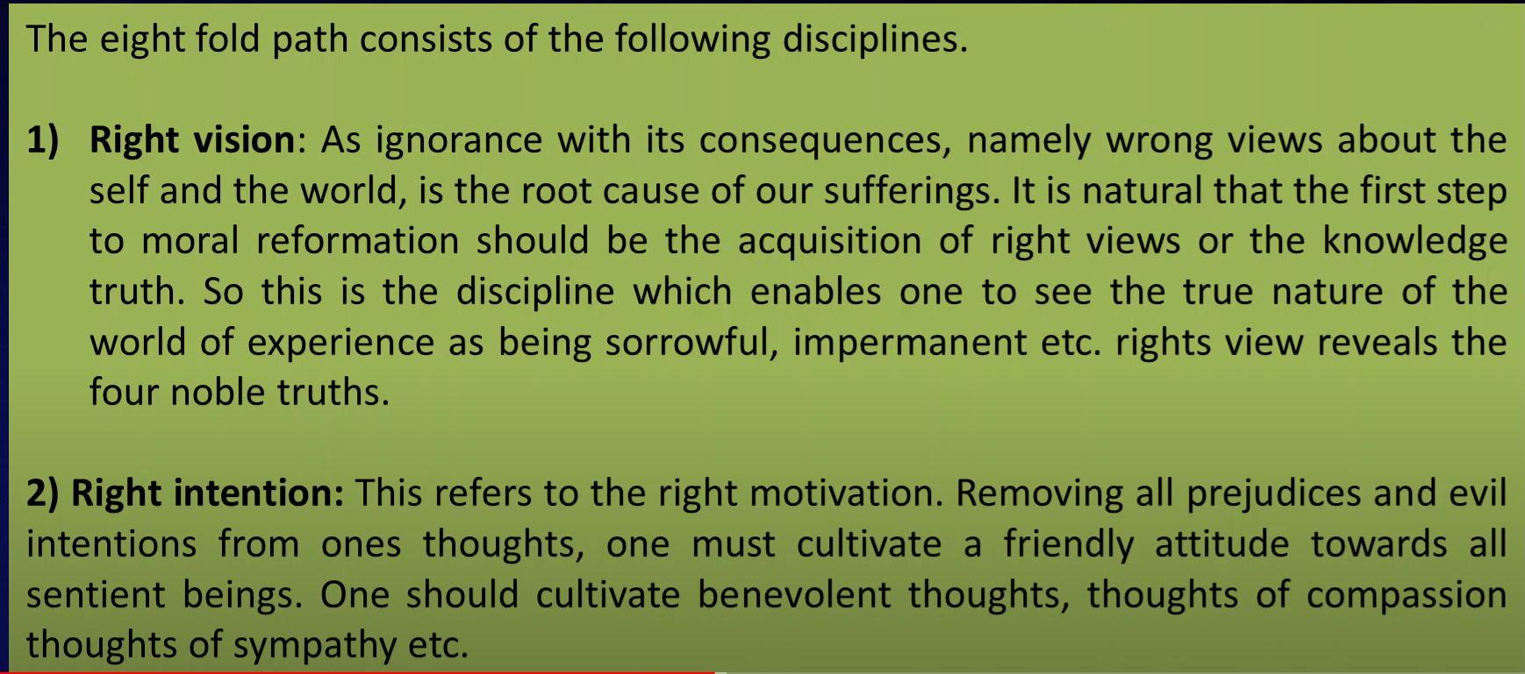

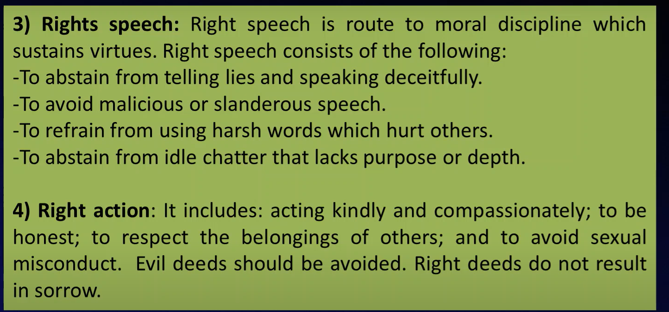

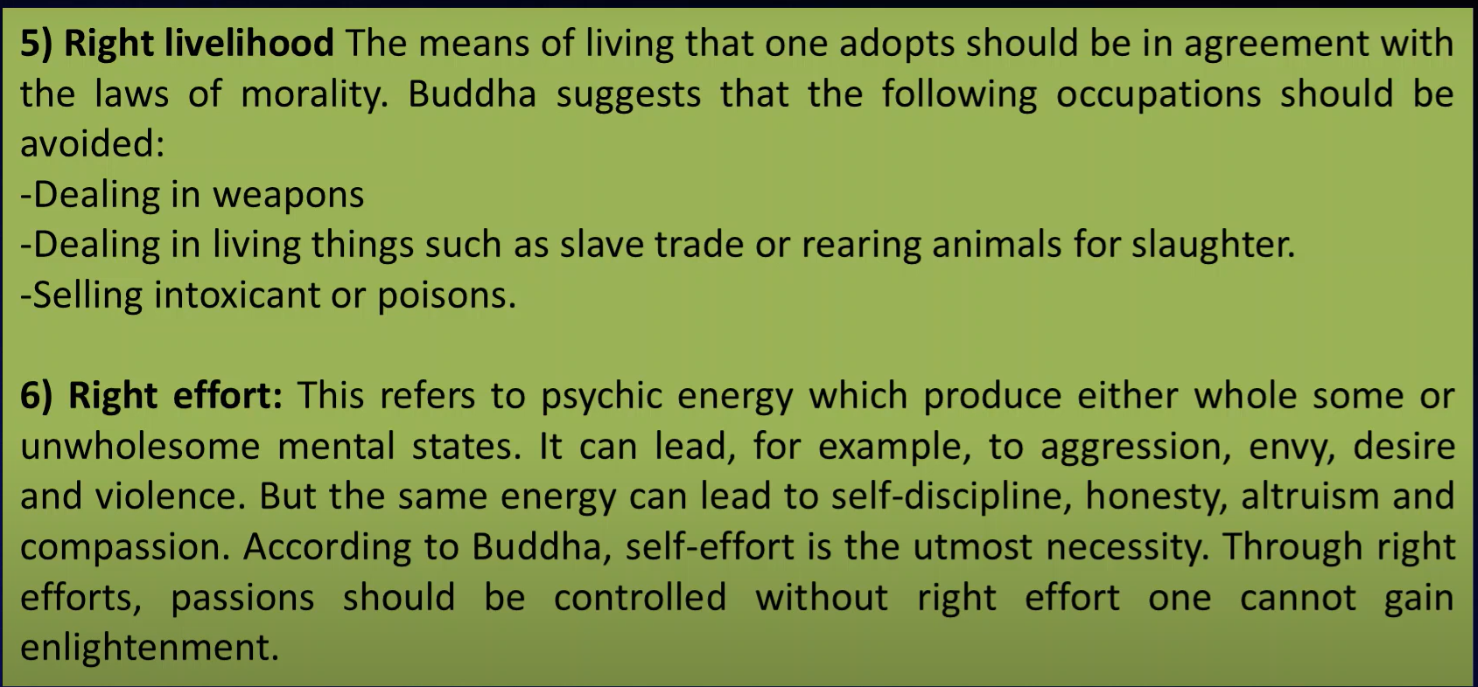

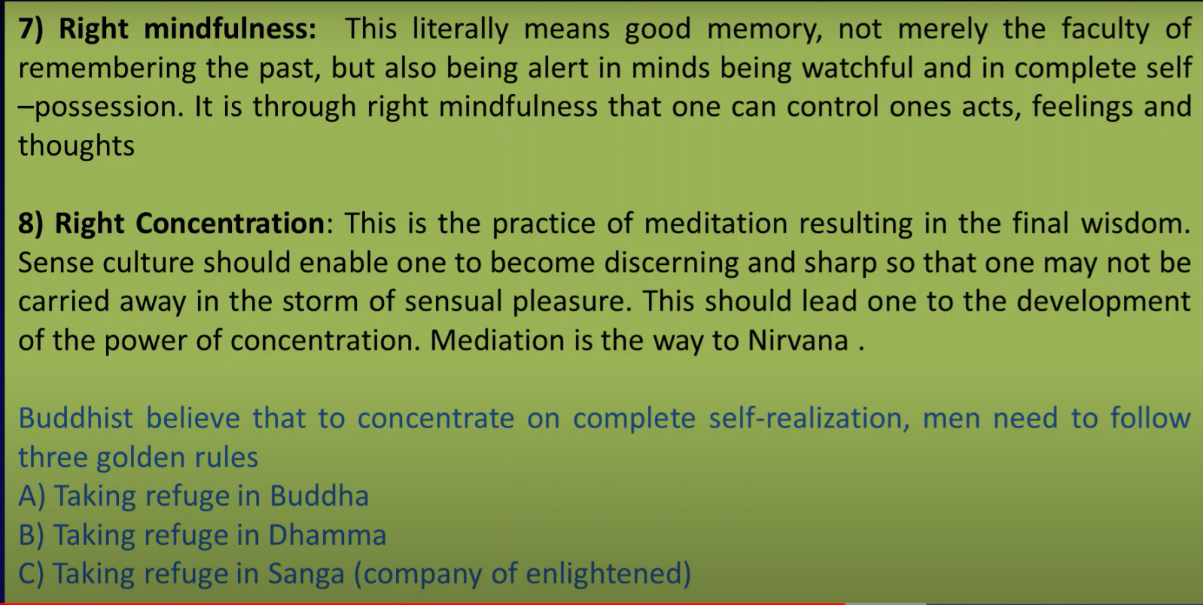

1. **The Theory of the non-existence of the soul**

One of the major and distinctive theses of Buddhism is the theory of “no-soul” – (or anatta in Pali, anatman in Sanskrit). This is part of a larger thesis that nothing has a real essence, the individual soul or self being here conceived as a special case of the concept of essence, i.e. as the essence of a person.

The Buddhist no essences doctrine arose in reaction to a thesis, labeled “Eternalism”, which was apparently normative in Indian philosophy at the time, that ‘things’ consist of eternal, unchanging ‘essences’, substantial and causally independent entities. Similarly, with regard to the special case of souls.

The Buddhist no essences doctrine was based on the assumption that the belief in such “essences”, including in particular the belief in souls (as the essences of our bodily and mental existences), is the root cause of our imprisonment in samsara (i.e. our fundamental ignorance and suffering), so that its abandonment would put us in nirvana (i.e. enlighten and liberate us).

1. **The Theory of Impermanence or momentariness**

The object of the Buddhist doctrine of momentariness is not the nature of time, but existence within time. Rather than atomizing time into moments, it atomizes phenomena temporally by dissecting them into a succession of discrete momentary entities. Its fundamental proposition is that everything passes out of existence as soon as it has originated and in this sense is momentary.

As an entity vanishes, it gives rise to a new entity of almost the same nature which originates immediately afterwards. Thus, there is an uninterrupted flow of causally connected momentary entities of nearly the same nature, the so-called continuum (santāna). These entities succeed each other so fast that the process cannot be discerned by ordinary perception.

According to this doctrine, the world (including the sentient beings inhabiting it) is at every moment distinct from the world in the previous or next moment. It is, however, linked to the past and future by the law of causality in so far as a phenomenon usually engenders a phenomenon of its kind when it perishes, so that the world originating in the next moment reflects the world in the preceding moment.

1. **4 Schools of Buddhism - Vaibhashika, Sautrantika, Yogachara and Madhyamaka (Too tough)**
2. **4 Ethical Teachings of Buddha – (All discussed above)  
   The Theory of Karma, Independent origination, Impermanence, Non-existence of soul**
3. **2 Religious Schools of Buddhism – Hanayana (or Hinayana) and Mahayana**

After the death of Buddha, Buddhism was divided into two sects namely Mahayana and Hinayana. The terms Hinayana (Lesser Vehicle or Modest Vehicle) and Mahayana (Greater Vehicle or Vast Vehicle) originated in The Prajnaparamita Sutras (The Sutras on Far-Reaching Discriminating Awareness, The Perfection of Wisdom Sutras).

**Hinayana**

Hinayana Buddhists regard Gautama Buddha as a regular human being who gained Nirvana. It refers to the lesser vehicle. The school is made up of followers of the Buddha’s original teachings. It is a more conventional school of thought that rejects the worship of Buddha’s idols or images. They believe in individual salvation and strive for it via self-discipline and meditation. Hinayana’s ultimate objective is Nirvana.

Inestimable joy in Hinayana Buddhism refers to relishing in the happiness of others without being jealous or expecting anything coming back. Hinayana Buddhists used the Pali language to connect with the general people. Emperor Ashoka supported the Hinayana religion.

**Mahayana**

This sect of Buddhism believes in the heavenliness of Buddha and believes in Idol Worship. Mahayan sect spread from India to several other nations such as China, Korea, Japan, Taiwan, Nepal, Tibet, Bhutan and Mangolia. Mahayana believes in Mantras. Its main principles were based on the possibility of universal liberation from suffering for all beings. That’ why, this sect is called Mahayana (The Great Vehicle). Its principles are also based on the existence of Buddhas and Bodhisattvas embodying Buddha nature. It allows salvation through having faith and committing oneself to Buddha.

**Major difference between Hinayana and Mahayana**

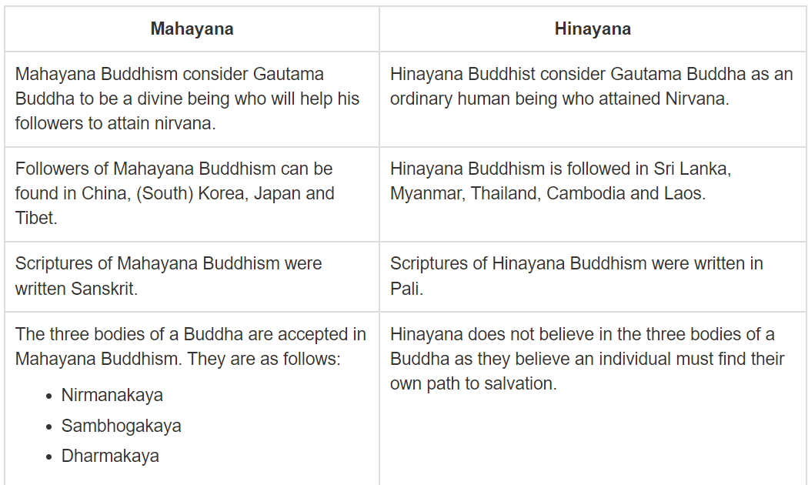

Mahayana worships the bodhisattvas and read the Mahayana sutras while Hinayanists do not perform these.

Mahayana Buddhism followers think that The Buddha is a God because they think that the Buddha came down to earth to help people cross the sea of life. So the Buddha can be worshipped as a God because he is eternal and comes down to earth.

On the other hand Hinayana Buddhists think that The Buddha was a Human instead of a God because they think The Buddha was simply a man who found a way to Nirvana.

1. **Short questions of Buddhism –**
2. **When was Buddha born, where?**

The Lord Buddha was born in 623 BC in the sacred area of Lumbini located in southern Nepal.

1. **What are the incidents that moved Siddhartha to find enlightenment?**

He saw four sights: a man bent with old age, a person afflicted with sickness, a corpse, and a wandering ascetic. It was the fourth sight, that of a wandering ascetic, that filled Siddhartha with a sense of urgency to find out what lay at the root of human suffering.

1. **Meaning of ‘Buddha’?** the enlightened one, a knower
2. **Countries that follow Buddhism?** Cambodia, Thailand, Burma (Myanmar), Bhutan, Sri Lanka, Laos and Mongolia
3. **3 Baskets of Teachings? What they are dealing with?**

The Three Baskets are called the Tipitaka in the ancient language of Pali and the Tripitaka in Sanskrit.  They identify the basic scripture or canon at the heart of Buddhism’s teachings.

What the Torah is to Judaism, the New Testament to Christianity, and the Koran to Islam, so are the Three Baskets to Buddhism.  They form the foundation of the written word or dharma.

The teachings are divided into three parts.  The Vinaya Pitaka is the collection of texts concerning the rules of conduct governing the daily affairs within the sangha (the community of monks and nuns during the Buddha’s time).  The Sutta Pitaka is the collection of discourses attributed to the Buddha, and the Abhidhamma Pitaka is the collection of texts concerning the nature of mind and matter.

**Short answer:** Each Buddhist sub-tradition had its own Tripiṭaka for its monasteries, written by its sangha, each set consisting of 32 books, in three parts or baskets of teachings: Vinaya Pitaka (“Basket of Discipline”), Sutra Pitaka (“Basket of Discourse”), and Abhidhamma Piṭaka (“Basket of Special [or Further] Doctrine”).

1. **Which school of thought in Buddhism adopted Sanskrit as medium of discussion and which follows Pali? Sanskrit – Mahayana, Pali – Theravada, Hinayana**
2. **What is ‘Catvari aryasatyani’? It’s the Four Noble truth in Sanskrit**(**‘Catvari aryasatyani’** = “The four Arya satyas”)
3. **At least 5 questions which are identified as uncertain, ethically unprofitable by Buddhism? \*\***
4. **What are the 12 links in the chain of causation in Second Noble truth of Buddhism?**

It is important to remember that dependent origination is essentially and primarily a teaching that has to do with the problem of suffering and how to free ourselves from suffering. The twelve components or links that make up dependent origination are:

(1) Ignorance, (2) Actions, (3) Consciousness, (4) Name and Form, (5) the Six Entrances (the five sense organs and the mind), (6) Contact, (7) Sensation, (8) Desire, (9) Clinging, (10) Existence, (11) Birth, and (12) Old Age and Death.

1. **The Theory of Pramanas – Nyaya**

**Nyaya -** Nyāya, literally meaning "justice", "rules", "method" or "judgment", is one of the six astika schools of Indian philosophy. This school's most significant contributions to Indian philosophy were systematic development of the theory of logic, methodology, and its treatises on epistemology.

In Indian philosophy, valid knowledge is called prama and the source of valid knowledge is called pramana. The way by which we can achieve valid knowledge is called pramana. As there is a detailed discussion about the pramanas in Nyaya Philosophy, so this system is also called ‘pramana-sastra.’

The analysis of the nature of pramana shows that there is no difference between the knowledge and pramana. Naiyayikas said that valid knowledge (prama) is of four types and the source of valid knowledge (pramana) are also of four types- pratyaksa, anumana, upamana and sabda.

**Pratyaksa (Perception):** Pratyaksa refers to the first of the four pramanas which in turn is classified as the first of the sixteen categories. Perception (pratyaksa) is the most primary and fundamental of all the pramanas. According to the Naiyayikas, perception arises after the contact of the sense organ with object. This contact may be of two types – ordinary or laukika and extraordinary or alaukika.

**Anumana (Inference):** There are two parts in the word anumāna. ‘anu’ meaning after and ‘mana’ meaning knowledge. Hence, the literal meaning of anumana is that it is a knowledge (mana) which originates after (anu) other knowledge.

**Upamana(Comparison):** Upamana refers to the third of the four pramanas, which in turn is classified as the first of the sixteen categories. Upamana can be stated as the source of knowledge of the relation between a name and the nameable object or between a word and its denotation. Upamana also means getting the knowledge of an unknown thing by comparing it with a known thing.

**Sabda:** Sabda refers to a sentence which is a means of valid knowledge is called verbal testimony. It is the fourth kind of valid knowledge in Nyaya philosophy, it is called Sabda or authoritative verbal testimony. It is defined as the statement of a trustworthy person and consists in understanding its meaning.

1. **The fallacies of inference in Nyaya. (Tough)**

In Nyaya Logic, a material fallacy is technically called hetvābhāsa, a word which literally means a hetu or reason which appears as, but really is not, a valid reason. The material fallacies being ultimately due to such fallacious reasons, the Naiyāyikas consider all these as being cases of hetvābhāsa. According to the Naiyāyikas, there are five kinds of material fallacies.

1. **The Nyaya Theology -The Idea and Proofs of existence of God.**

God is the ultimate cause of creation, maintenance and destruction of the world. God is the eternal infinite self who creates. maintains and destroys the world. He does not create the world out of nothing. but out of eternal atoms. space. time. ether, minds and souls. The creation of the world means the ordering of the eternal entities, which are co-existent with God into a moral world. Eternal consciousness is only an inseparable attribute of God, not His very essence, as maintained in the Advaita Vedanta. He possesses to the full all the six perfections and is majestic. almighty, all glorious. infinitely beautiful and possessed of infinite knowledge and perfect freedom from attachment.

Just as God is the efficient cause of the world, so He is the directive cause of the actions of all living beings. Nyaya gives the following arguments to prove the existence of God:

1. The world is an effect and hence it must have an efficient cause. This intelligent agent is God. The order, design. co-ordination between different phenomena comes from God.

2. The atoms being essentially inactive cannot form the different combinations unless God gives motion to them. The Unseen Power, the Adrsta, requires the intelligence of God. Without God it cannot supply motion to the atoms.

3. The world is sustained by God’s will. Unintelligent Adrsta cannot do this. And the world is destroyed by God’s will.

4. A word has a meaning and signifies an object. The power of words to signify their objects comes from God.

5. God is the author of the infallible Veda.

6. The Veda testifies to the existence of God.

7. The Vedic sentences deal with moral injunctions and prohibitions. The Vedic commands are the Divine commands. God is the creator and promulgator of the moral laws.

8. According to Nyaya the magnitude of a dyad is not produced by the infinitesimal magnitude of the two atoms each, but by the number of the two atoms. Number ‘one’ is directly perceived, but other numbers are conceptual creations. Numerical conception is related to the mind of the perceiver. At the time of creation, the souls are unconscious. And the atoms and the unseen Power and space. time. mind are all unconscious. Hence, the numerical conception depends upon the Divine Consciousness. So God must exist.

9. We reap the fruits of our own actions. Merit and demerit accrue from our actions and the stock of merit and demerit is called Adrsta, the unseen power. But this Unseen Power, being unintelligent. needs the guidance of a supremely intelligent God.

1. **The Nyaya Theory of the Physical world.**

The physical world is constituted by the four physical substances of earth, water, fire and air. The ultimate constituents of these four substances are the eternal and unchanging atoms of earth, water, fire and air. Akasa or ether, kala or time, and dik or space is eternal and infinite substances, each being one single whole.

Thus, the physical world is the product of the four kinds of atoms of earth, water, fire and air. It contains all the composite products of these atoms, and their qualities and relations, including organic bodies, the senses, and the sensible qualities of things. Thus, the self, its attribute of knowledge and manas are not at all physical.

Time and space are two substances which although different from the physical substances, yet somehow belong to the physical world. Akasa is a physical substance which is not a productive cause of anything.

1. **Nyaya vs Vaiseshika**
2. Nyaya is a system of atomic pluralism and logical realisin. It is allied to the Vaisesika system which is regarded as ‘Samanatantra or similar philosophy.
3. Vaisesika develops metaphysics and ontology. Nyaya develops logic and epistemology.
4. Both agree in viewing the earthly life as full of suffering, as bondage of the soul; liberation is absolute cessation of suffering as the supreme end of life.
5. Both agree that bondage is due to ignorance of reality and that liberation is due to right knowledge of reality. While the Vaisesika recognizes seven categories and classifies all real under them, the Nyaya recognizes sixteen categories and includes all the seven categories of the Vaisesikas in one of them called prameva or the knowable, the second in the sixteen.
6. Secondly, while the Vaisesika recognizes only two pramanas, perception and inference and reduces comparison and verbal authority to inference, the Nyaya recognizes all the four as separate — perception, inference, comparison and verbal authority.
7. **What do you mean by Darwinism and anti-Darwinism.**

**Darwinism** is a theory of biological evolution developed by the English naturalist Charles Darwin and others, stating that all species of organisms arise and develop through the natural selection of small, inherited variations that increase the individual's ability to compete, survive, and reproduce.

**Anti-Darwinism**: opposed to or at odds with the evolutionary theories of Charles Darwin.

1. **Difference between Eastern and Western Philosophy.**

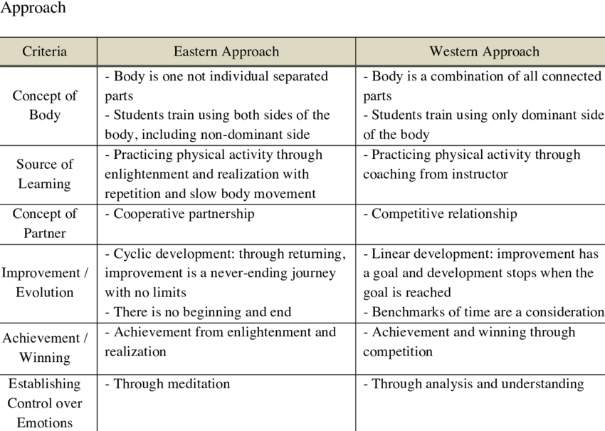

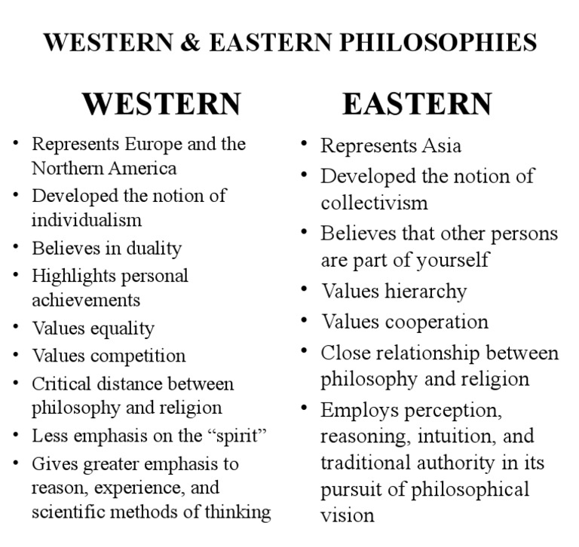

* Western philosophy deals with Individualism while Eastern Philosophy is related to Collectivism.
* Eastern philosophy takes more of a spiritual approach while Western philosophy is more hands-on.

1. **What do you understand by the word Ethics? What are the basic differences between Charvaka ‘s view of Ethics and Jaina’s view point of Ethics?**
2. **Who are Thirthankaras and who is the founder of Jainism?**

Tirthankara also called Jina (“Victor”), in Jainism, a saviour who has succeeded in crossing over life's stream of rebirths and has made a path for others to follow. Mahavira (6th century bce) was the last Tirthankara to appear.

Rishabhadeva is considered as the first real founder of Jainism. He is the first Tirthankara in Jainism and is also said to have live million years ago.

1. **What is the difference between Svetambaras group of people and Digambaras?**

Digambaras and Svetambaras are two sects of Jainism. The main difference between Digambaras and Svetambaras was that the followers of Digambaras did not wear any clothes and followed the original teaching of Mahavira. But the followers of Svetambaras wore white clothes and did not believe in hard penance.

1. **Why do the Jains consider “Consciousness is the inseperable essence of every soul”-Define in your own words. What do you understand by Liberation in Jain theory?**

Jain philosophy has a unique perspective on consciousness. Jainism regards consciousness as the most fundamental and intrinsic feature of the soul. Consciousness (cetanā), in Jainism, is an essential and defining perennial activity of the soul (ātmā) and cannot exist without the soul. According to Jainism, not only humans but also the animals, plants and the natural elements such as air, water, fire and earth have potentially infinite consciousness.

Consciousness (cetana) manifests itself in several ways: intelligence, knowledge, intuition, bliss, perception (cognitive elements), emotions, will, attitude and behaviour, awareness of pleasure and pain. Life and consciousness are coextensive. Wherever there is life, there is consciousness and vice versa. But there are degrees of explicitness or manifestation of consciousness in different organisms. In the lowest class of organisms, it is very much latent, while in human beings, it is very much manifest. Jiva is entirely distinct from inanimate existence, which does not possess consciousness.

**Liberation in Jainism**

The ultimate purpose of all life and activity in Jainism is to realize the free and blissful state of our true being. True philosophy should result in removing all bondage (karma) in the process of purifying the soul.

The central theme of Jainism considers religion as a science of ethical practice. The conduct of the present life should be aimed to attain total freedom from which there is no return to the birth and death cycle. Every soul can attain liberation and supreme spiritual state by realizing its intrinsic purity and perfection.

Jainism lays down a definitive course of practical moral discipline, contemplation of the highest truth, and reorientation of life in light of these for attaining ultimate reality or truth.

The principle features of Jainism are:

* Religious tolerance
* Ethical purity
* Harmony between self and one's environment
* Spiritual contentment

Jainism prescribes a path to liberation (Moksha), consists of the following trinity (ratna traya):

* Right perception (Samyak darsana)
* Right knowledge (Samyak jnana)
* Right conduct (Samyak charitrya)

1. **Buddhism is divided into how many sections. Name and define in nutshell.**

**Divisions of Buddhism**

There are two main divisions in Buddhism: Theravada Buddhism and Mahayana Buddhism.

**Theravada Buddhism**

Theravada Buddhism is older and the more conservative of the two main divisions of Buddhism and is often referred to as the ‘traditions of the elders’. Many Theravada Buddhists follow the teachings of the Buddha exactly, and many of them are monks or nuns.

Theravada Buddhists strive to be arhats. Arhats are perfected people who have gained true insight into the nature of reality. This means they have followed the Noble Eightfold Path to ‘blow out’ the three fires of greed, hatred and ignorance and have become enlightened. In Buddhism, enlightenment leads to nibbana (or nirvana), which means freedom from the cycle of rebirth (samsara). Consequently, they will no longer be reborn through samsara.

**Mahayana Buddhism**

Mahayana Buddhists believe they can achieve enlightenment through following the teachings of the Buddha. The goal of a Mahayana Buddhist may be to become a Bodhisattva and this is achieved through the Six Perfections. Compassion is very important in Mahayana Buddhism. Therefore, Bodhisattvas choose to stay in the cycle of samsara to help others to achieve enlightenment as well as themselves.

This is a key difference between Theravada and Mahayana Buddhists. Whereas Theravada Buddhists strive to become Arhats and gain freedom from the cycle of samsara, Mahayana Buddhists may choose to stay in the cycle of samsara out of compassion for others.